Beautiful Hydrangeas
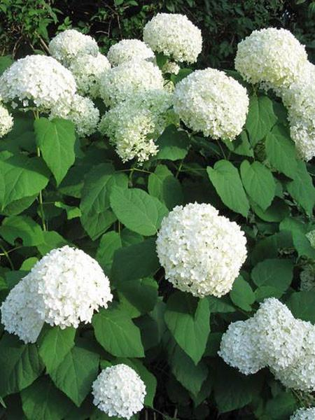
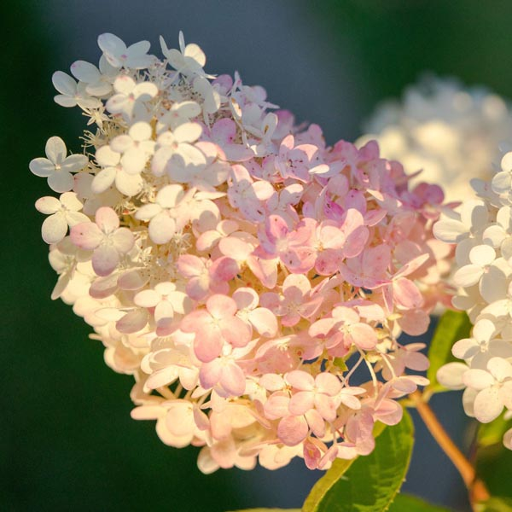
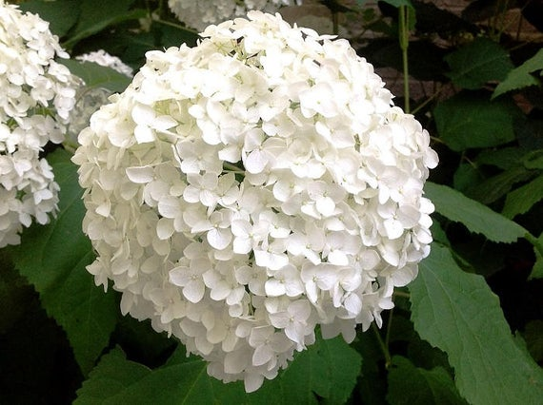

Pannicle hydrangea (hydrangea paniculata)
Annabelle Hydrangeas (smooth hydrangeas)

Many gardeners find that as they age they want to spend less time tending to fussy annuals and perennials, but still want to have pretty blooms in their gardens. That is a job that shrubs do beautifully.
When shopping for shrubs, hydrangeas are a really popular choice, both as a single three foot tall shrub in a perennial garden, an eight feet tree in the yard, or even as a hedge. Hydrangeas are easy to grow, rarely bothered by diseases or pests, there are varieties available for both sun and shade, and they are long blooming and late blooming – many blooming from late summer well into the fall. Their blooms can be spectacular, both in the garden and in a vase. In many ways, they are easy-care plants, but there are a few common mistakes that we need to avoid, or correct. This article has a few tips to be sure that your hydrangeas are as beautiful as you’d hoped they’d be, and a few tips on shopping for them if you don’t currently have one in your garden. Don’t let all of the details on their care make you think that these are fussy plants or hard to grow. These tips will just help you make your plant as gorgeous as it can be! Lastly there’s a word of caution on a pest that is in our area right now that you will want to keep an eye out for if you grow Annabelle Hydrangeas.
Tips for Care and Shopping For a New Hydrangea
1. Is the hydrangea zone hardy here? The first thing you should know is that not all hydrangeas are hardy here. We often see beautiful potted ones for sale around Easter. Sadly, they won’t return if we plant them in a garden. The hydrangeas that do overwinter really well here are the panicle type (hydrangea paniculata) and smooth type (hydrangea arborescens). It’s also important to know that their preferred location in your garden changes as the zones get lower. The farther north you are, the more sun your hydrangeas can handle. So when you Google some types that say they need shade, they may actually need morning sun here in Moncton, with some dappled shade for the rest of the day. Others might survive if given more protection than what you might see on the plant label. For example, Endless Summer was a big breakthrough when they announced it would bloom on old and new wood. The problem was that in Moncton, the old wood often didn’t survive the winter, and the new wood often didn’t bloom until so late in the season that frost threatened to take it out. A hardiness zone and shopping list can be found at the end of this article!
2 Are you watering enough? The word “hydrangea” comes from the Greek words hydro (or "water") and angeion ("vase") – "water vase." This should remind you that this is a plant that always enjoys a good watering. But remember that they also demand well drained soil. They don’t want wet soil – just moist soil. Hydrangeas also prefer soil that is rich in nutrients - heavy clay and sand-like soils aren't ideal for this plant. However, when you amend the soil with compost or other organics to improve drainage, you’re also adding nutrients they need and they’ll thrive in amended soil.
3. Don’t attempt to change the colour. It seems that every spring, new varieties of hydrangeas show up in nurseries - pink, white, lime green, blue, purple… But for most of the kinds of hydrangeas that we can grow here in Moncton, we can’t “alter” that colour. As the flowers age, they often take on changing tones and/or different colours, going from white or lime green to pink or bugundy. That’s one of the things that many gardeners find so appealing, but it is just the nature of that plant – it has nothing to do with soil pH. The truly hardy hydrangea flowers that we can grow here are totally unaffected by the soil's pH level. For the most part, we can’t grow the ones that turn purple in acidic soil and pink in alkaline soil. Those plants are only hardy to about Zone 7. Endless Summer is an exception, and it will bloom blue in acidic soil and pink in alkaline soil, but as mentioned above, there is a lot of debate about whether it truly is zone hardy here. It seems that it can be grown but requires the perfect growing conditions. But if you have any other hydrangea plant that has blooms that are pink, you can’t assume that your soil in that area is alkaline!
4. You are not sure what shape your blooms are. When you Google how to prune hydrangeas, or how often to feed them, or how much sun they need, the first question will always be, “Are you growing a panicle or a smooth variety?” Sometimes it’s not all that easy to tell! Panicle hydrangeas are always described as having “cone shaped” flowers, but that cone shape can be very distinct – or VERY vague – depending on the variety. Some are pretty darned close to being round! The size of the flowers also ranges among the varieties. “Smooth” hydrangeas are usually easier to identify – they have large dome-shaped flowers which are typically six to twelve inches across, based on the variety. If you grow a lot of different hydrangeas, it’s always a good idea to label them in some way so that you won’t later mistake the type that you have when you’re trying to decide what type of pruning it needs. But there are easy ways to identify the plant type, even if you aren’t sure if the bloom is cone shaped or smooth. Panicle hydrangeas have woody, sturdy stems, whereas smooth hydrangeas have green, flexible, relatively soft stems. This is because panicle hydrangeas regrow on previous season's growth and smooth hydrangeas grow up new from the ground each year. (Panicle hydrangea leaves also tend to be darker green and more leathery; smooth hydrangea leaves are lighter green and softer).
5. Am I giving my hydrangeas too much sun or too much shade? Most hydrangeas love morning sun and afternoon shade. They’re often recommended for shade gardens in magazines, but as mentioned earlier, that is only for those who are growing them farther south in a higher zone. Up here, many – not all – can take a lot more sun. Shop at a nursery with knowledgeable staff and ask them about the conditions needed by the specific plant you are buying.
6. When should I prune? Hydrangeas should never be pruned in the fall. They set flower buds for the following season in fall, so if you cut it back, you could be cutting off all of the blooms. They should be pruned in the spring—preferably around Father's Day, if you can possibly wait that long. You want to be sure you're not cutting off any old wood that is dormant and late to come back, because you'll be removing your blooms if you have one that blooms on old wood. Smooth (hydrangea aborescens) are very popular in Moncton gardens – especially the variety, Annabella, which has big flowers that are actually made up of many small individual blooms. They start out green but turn white a few weeks later. Since it blooms on new wood (stems that have grown during the current season), it should be pruned in early spring before any flower buds have appeared. This hydrangea is very popular with crafts people who love to dry and spray their blossoms for a permanent dried display.
7. How much fertilizer do my hydrangeas need? Some gardeners assume that any plant that produces so many huge blooms must need to be fed a lot, and they might fertilize them every week or two all summer. Adding fertilizer weekly can add too much nitrogen to the soil, which can actually slow bloom production. Instead, experts recommend fertilizing hydrangeas as the plant is "first waking up" in the spring—and one more time when the buds are just beginning to bloom. They say that the extra energy at those times will really help with getting more blooms.
Pest Warning!
As mentioned at the beginning of this article, if you grow Annabelle Hydrangeas, you should take a minute to run to the garden and check them for a pest that is in our area right now. Get out there and look very carefully to see if there is any sign of leaves and/or flower buds being stuck together. While hydrangeas don’t have a lot of pests, there is one that is active right now, and it will require immediate attention if you have it! Don’t let this stop you from buying and growing hydrangeas, but do pay attention and be on the lookout! It seems that this insect only attacks the smooth hydrangeas; the panicle type don’t seem to be bothered by it.
(There are actually two different insects that could be causing a problem, and the damage looks quite similar, but the more common one is the hydrangea leaf tier larva). It binds two or as many as four leaves together with strands of sticky silk and then it lives and feeds while it’s tucked away safely inside. If you gently pull the leaves apart you will see a small slender greenish caterpillar with a blackish head. After it stops feeding, the caterpillar will drop to the ground to pupate over the summer and emerge as an adult moth next spring.
(A different insect that causes similar damage is the leaf roller. In this case, the caterpillar rolls up only one individual leaf, binds it with strands of sticky silk, and then feeds and rests within the rolled or folded leaf. )
For both of these insects, they can make your hydrangea look quite ugly, and they can cause you to lose your bloom for a year, but they rarely destroy your plant, and if you find them early enough and destroy them, your plant will have enough time to grow and flourish and bloom. Just make sure that when you’re removing the stuck together branches that you don’t leave any of them lying on the ground under your plant. Because it occurs early in the spring, if you remove the infested leaves and squash or drown the caterpillars, the plant will have time to grow and flourish over the summer.
The leaf-tier worm only seems to attack the smooth white flowered hydrangeas. It’s the larvae of a small brown moth. Since we grow Annabelles for their gorgeous flowers and not their leaves, it’s important to kill the worm before it eats the flower buds. Other beneficial insects, birds, or insecticides can’t do the job since it’s wrapped up so tightly inside the sticky leaves. Because the caterpillar is so sheltered, most pesticides are ineffective. Hand removal sadly is the best option.
After about ten days, the caterpillar stops eating and morphs into a chrysalis. About a week later, the adult moth appears and heads off for the summer, but then it returns in late fall to lay its eggs. There is only one generation per summer, but we need to deal with the larvae that are in our gardens NOW, and then we need to be sure that in the fall they aren’t able to stay and create the same problem next spring.
To nip the current season’s infestation in the bud, open the leaves manually, then hand pick the caterpillar and either crush it or drop it into soapy water. If you do that soon after the leaves are tied together, you can save this season’s bloom.
Saving hydrangea flowers by opening the leaves one by one is not such a terrible chore (OK – yes, it’s gross!) when it happens just once. It’s a major annoyance, though, if it happens every single spring. And once the leaf-tier is in your neighborhood, it does tend to come back year after year.
It’s important to understand that the moth lays her eggs on hydrangea stems in the late fall, usually only one per stem. The eggs overwinter there, then, in early spring, as the shrub buds out, the young caterpillars crawl up the stem to the upper leaves and begin to hide inside. Luckily, good pruning can help! Early in the spring, cut your smooth hydrangeas back as close to the ground as you can. Since this species flowers on new wood, this will not affect its blooming, and if you pick up the pruned stems, you’ll have eliminated most of the leaf-tier’s eggs that were on them. Just be sure you don’t leave a single leaf or stem on the ground!
The only problem is that the female moth is smart! She tends to lay her eggs low down on the stem, sometimes so low you can’t cut back that far. It’s important to know how the new regrowth comes up in the spring. When you cut them back, you need to be sure that you are leaving two “eyes” on each stump – that is where your new growth will sprout from. So if you cut BELOW that to rid yourself of the eggs, you are also ridding yourself of any new growth at all!!! From every old shoot two new ones develop, which is why the hydrangea becomes bigger as it ages. (If some branches grow too close and it starts to look too crowded, the plant should be thinned out a bit). Also, you should remember that any stunted or unwelcome shoots can be cut off during spring and summer without harming the plant at all. But when you’re cutting them back hard in the spring, if you prune the plant back to about 10 cm, you will likely get most of the caterpillars. You can then open the sticky leaves of the few insects that do survive as soon you notice them.
Another possibility is to spray the stems with BTK, a biological insecticide, as soon as they show the first signs of growth. That will kill the caterpillar as soon as it emerges from the egg. BTK has been proven safe and environmentally friendly by every possible health agency and agricultural agency. It is only effective on true caterpillars, but it is VERY effective on those.
Another option is to snip off the damage. When you spot the first leaves being stuck shut on the tips of your hydrangeas, simply snip the curled leaf tips off the plant down to the next leaf node. Toss them in the garbage with the caterpillar still inside.
Depending on how long the caterpillars have been feeding, the flower bud may already be damaged beyond repair when you spot them. But it’s not time for total panic! Removing the damaged tips as soon as they are spotted encourages side-shoot production. These side-shoots often will go on to produce a second set of buds and, eventually, flowers. So you might have your bloom time a bit later in the season, but at least you’ll still have the bloom!
If you are shopping for more hydrangeas for your gardens, there are lots to choose from. Here are a few of the best choices for this area. (Some garden centres do sell some that are NOT zone hardy here and are meant to be grown as an annual in a pot on your deck, so read tags carefully, or google the variety before you buy if a zone isn’t listed. I’ve seen a few local gardeners who bought ones this spring advertised as a “tree hydrangea” that are NOT hardy here!)
• 'Annabelle' – Mid- to late-summer blooming with huge, white globelike blooms. Prune to the ground in the spring. Blooms on new wood. Hardiness zones 4 to 9; It loves a spot with some morning sun but shade in the afternoon, or some dappled light all day -deep shade and midday heat should be avoided because they will both cause less blooms and a less healthy plant. A sheltered location is also recommended, as those big blooms are held up by soft stems – a windy spot will often lead the stems to snap off. Remember that this one needs to remain well watered. Drooping leafs are a clear sign your plant is thirsty and needs to be watered immediately. Try to never let it get to the point that you notice it wilting! But also be sure that it’s in well draining soil. If you see the leaves turning yellow, your soil could be holding too much water!
• 'Limelights' – This one is a good choice if you want the tree or large shrub form. It has huge cone-shaped chartreuse green flowers that bloom from midsummer to late fall. It has a hardiness rated to Zone 3, so will have no problem surviving winter here. It needs full to partial sun. The limelight can grow 10 to 20 feet tall and wide. Limelight hydrangeas bloom in creamy white and lime-coloured blossoms that are large, showy and tinged with pink in the fall. Water your limelight hydrangeas deeply and thoroughly to soak the soil around the roots once each week during the summer when rainfall is less than 1 inch. They are more drought tolerant than some other hydrangeas, but still prefer a drink of water from time to time! Keep the soil constantly and evenly moistened at all times while the hydrangeas are actively growing. It’s a good idea to spread a 1-inch-thick layer of organic compost on the ground around the limelight hydrangeas once each year in spring. Spread the compost to the entire canopy area under your tree. Apply a layer of bark or wood chip mulch on the ground around the limelight hydrangea to keep weeds out, and preserve soil moisture. As with ALL trees, keep the mulch about 2 inches away from the trunk.
Prune your limelight hydrangea during summer and autumn to remove faded flower blossoms. This will keep the hydrangea healthy and encourage it to grow new blooming stems. You can cut back your limelight hydrangea by about half its size in mid-fall, when the growing season ends. Doing this will encourage the hydrangea to grow back larger and with more flowers the next spring as it blooms on new wood One of the things gardeners love about this hydrangea is that its hugs blooms remain pointing upward and don’t droop down like some others do It blooms a bit later than other hydrangeas so gives you great fall colour.
There is one important thing to remember about the limelight flowers. Try to avoid getting water on the flowers when you’re watering the plants, especially during the hotter parts of summer. Splashing water on the blossoms can cause the flowers to turn brown. Always water at the base!
•Peegee Hydrangea is another extremely cold hardy choice. It is the white-flowering paniculata form that becomes a large shrub or small tree, and is by far the one you see most often in our Moncton area.
• 'Endless Summer' – As mentioned earlier, the verdict is still out on its overall performance in Canada. However, when it grows well, this is said to be a continuously blooming garden plant that starts flowering in midsummer and has blue or pink flowers (blue with acidic soil, pink with alkaline soil). It was originally sold with a hardiness rating of Zone 4, but there is talk of changing this to a 5 or even a 6, due to so many gardeners finding that it wasn’t really very hardy at all! Often when new plants like this are developed, the breeders rush them to market without giving them long enough in field trials to see how they really perform. If you’re a gambler, it might be worth a try!
It is true that some gardeners have had success growing Endless Summer here. If you’re still trying to get one to bloom well, there are some tips from the breeders for those of us in areas with such cold winters. Leaving the fall blooms on your plants over the winter provides winter interest, but more importantly, it ensures you aren’t removing buds that will become flowers in the spring and summer. Leaves, wood mulch and/or straw are often needed to insulate your plants. Mound the mulch or leaves around your plants at least 12” high to protect the flower buds so that they may bloom next year. In the spring, do not remove the mulch too fast; wait until all danger of frost has passed (based on this year – that could be the end of June!!!) before uncovering to ensure beautiful blooms from old and new wood. The “old wood” buds will provide early season colour and the blooms forming on current season growth will typically occur roughly six weeks later and last through the end of the season. But also, be sure you put a plant like Endless Summer in a spot that is protected from winter winds – or…. stick with ones that are hardier!
Climbing Hydrangeas are beautiful vines that can climb to anywhere from 20 to 50 feet tall and there are ones that are hardy to Zone 4. Just be sure that you have it climbing on a VERY solid structure! A climbing hydrangea plant clings to the supporting structure by two methods — twining vines that wrap themselves around the structure, and aerial roots that grow along the main stem which cling to vertical surfaces.
You might be surprised to learn that without a supporting structure, climbing hydrangea plants form a mounding, arching shrub that grows to a height of about 1 meter (3 to 4 feet). They can be slow to become established, but later spread quite quickly. The aerial rootlets that grow along the main stem take root wherever they make contact with the soil, and this potential to spread makes a climbing hydrangea plant an excellent choice as a ground cover for a large area!
Bigleaf Hydrangea (Hydrangea macrophylla ) can’t be grown in our part of Canada – but you may see them growing on Vancouver Island – and you may see them for sale in some nationwide chain stores! They are best left on the shelf!
Oakleaf Hydrangea is another one that you might see for sale locally but it is “marginally” hardy. They can be safely grown in southern Ontario, but would need a VERY protected site and perfect soil and growing conditions here in Moncton. You may see varieties of this one such as 'Alison', 'Harmony', 'Snowflake' and 'Snow Queen'.
No matter what style of garden you have, it’s worth looking around to see if you can find a spot for your first (or tenth) hydrangea. There are very few plants that have prettier blooms, and if you choose one that you can provide the perfect spot for, they really are close to being a carefree addition to your garden!

