Ask Dr. Fill
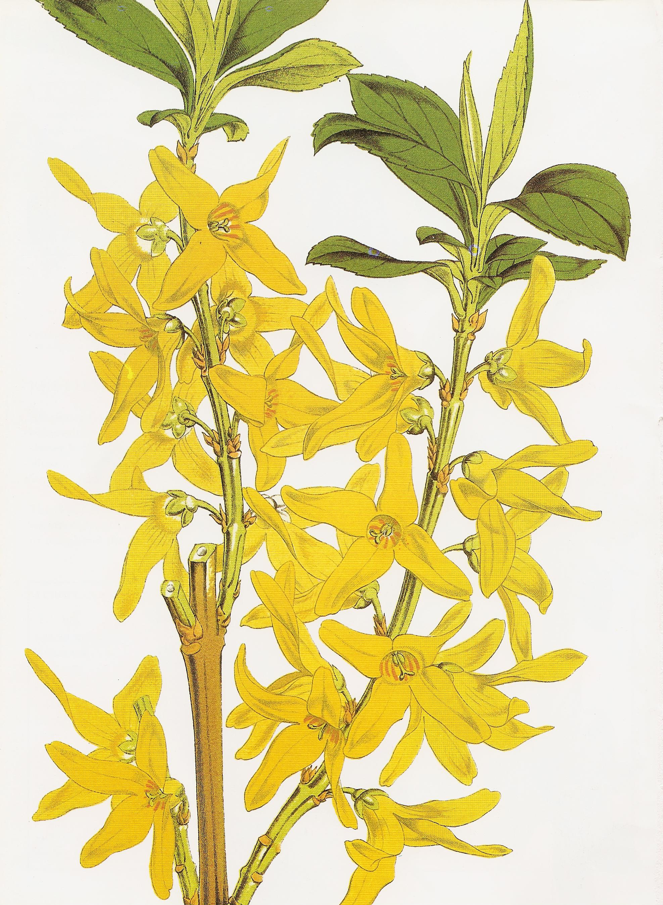
Dear Dr. Fill …………. My forsythia shrubs are vigorous and healthy, but didn't bloom well last spring. I did have a few blooms near the bottom of the tree. What am I doing wrong?..Is there anything I should be feeding them to get them to bloom more this spring? Sincerely, Bloomless
Dear Bloomless
There are a few possible reasons for poor bloom on a forsythia. Forsythias bloom on old wood, which means that their flower buds were set last year and were on the tree all winter. Unfortunately, the flower buds on some varieties are not reliably cold hardy in Moncton. Forsythias sold at local nurseries should be cold hardy varieties, but I have seen some for sale at “national” chain stores which wouldn’t always survive a Moncton winter.
This lack of hardiness seems the most likely cause. The fact that your lower branches bloomed is likely because they were covered with snow and protected from the cold winter temp-eratures. It can be quite tricky with shrubs that bloom on old wood, as the hardiness rating is for the plant itself – NOT for the flower buds. Many people don’t realize this when they are choosing spring blooming shrubs. So cold weather can certainly kill flower buds and not harm the tree. Most gardeners don’t think to ask about the hardiness of the flower buds themselves, and many of us wouldn’t buy the shrubs if we knew that they would survive our winters, but only bloom after a mild one. If you did plant one that is not Zone hardy here, and you want to replace it, you might want to look for 'Meadowlark' which has very hardy flower buds, or ‘Northern Sun’ or ‘Northern Gold’ or ‘Ottawa’. And in the future, it’s always a good idea when you’re shopping for spring blooming shrubs to ask if the hardiness rating includes the flower buds themselves, or just the green shrub. Most gardeners wouldn’t purchase a plant that won’t reliably bloom.
Improper pruning is another very common cause for many spring flowering shrubs not blooming as well as they should. Flower buds on forsythias begin to develop by early summer. Therefore pruning the shrubs anytime from mid-summer until just prior to bloom will drastically reduce flowering as you’ve cut off all the flower buds. To achieve the best spring bloom, forsythias should be pruned immediately after flowering. And most varieties, especially older ones, do need to be pruned then, or they can become quite out of control.
Another possibility for you to consider is whether there is a new tree or building or something nearby that is putting your forsythia in shade now when it used to be in full sun. Without six hours of sunlight, your forsythia won’t bloom nearly as well as it could.
You also might want to check the soil around the base of your tree. Forsythia are quite forgiving about the soil they’re growing in, but during bloom time, they prefer not to be dry and will bloom poorly if they’re really thirsty.
A less likely possibility is a change in your soil. If you’ve begun to use a very high nitrogen lawn fertilizer near where your shrub is planted, that might be causing the lack of bloom. The fact that you said you do have some blooms lower down on your tree likely rules this out, but it might be worth considering. Sometimes shrubs planted in lawns do suffer a bit from too much nitrogen forcing a lot of new green growth, and the plant then doesn’t have the strength to bloom.
I sent Claudia one on daffodils to send out May 5 so this could be for May 12.
One last thing to consider is the age of your plant. A forsythia that will not bloom may just be too old. You can try lopping the plant back to the ground and hope the new growth will rejuvenate the bloom, but maybe it’s time to begin again with a newer variety that you know will be a good bloomer in our area. It’s possible that the blooms that you were seeing on the bottom were on newer shoots that were springing up around the older original branches.
You asked about whether you should be adding fertilizer. Like most flowering shrubs, forsythia don’t want to be fertilized too much as it can cause them to literally bloom themselves to death. They shouldn’t be fertilized at all in their first few years if they were planted in decent soil with some compost added to the soil. As the shrub gets older, you can top dress with some compost, or if you prefer to use commercial fertilizers, you could feed it at half strength once or twice a year.
Thanks for the question and hopefully next spring you’ll have those beautiful yellow blooms covering your forsythia. Dr. Fill

