Ask Dr. Fill
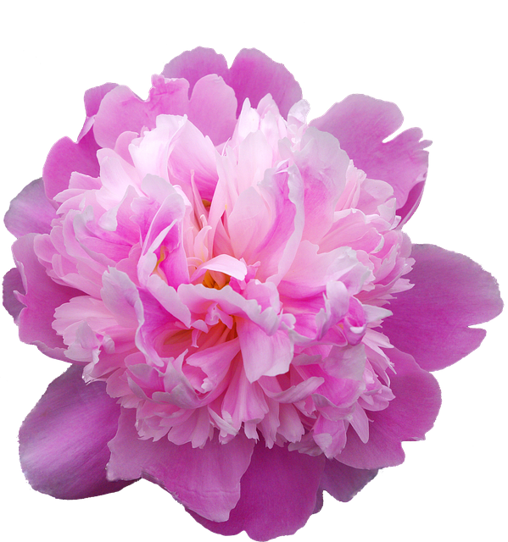
Dear Dr. Fill……………… I’d always heard that ants are needed on peonies to force the buds open. Then I read somewhere that this is not true at all, and that the ants are just there because they want the sweet nectar. But I was reading an article online bout peonies and it mentioned that they do need the ants, so I’m now really questioning whether it’s a myth or not. Could you please settle this once and for all? Sincerely, A Curious Peony Grower
Dear Peony Grower ….. Every year during peony season you’ll hear people talking about the fact that you need to have ants on your peonies. It is definitely a myth that the ants force the buds open, but it’s a myth I also see repeated on some on-line gardening sites. Peonies and ants do have an interesting relationship, but the peony could bloom just fine without the ants. However, those of us with peonies in our garden may certainly see lots of ants.
The relationship between peonies and ants is very interesting. In biology, there are 3 types of relationships between various living things, and they are usually very obvious. With ants and peonies, it gets com-plicated! The 3 types are mutualism, symbiotic, and parasitic. When it comes to ants and peonies, you can see all three at work, which is very unusual. When a relationship is one of mutualism, both individuals benefit in some way. One example of this is one breed of little bird that happily perches inside the mouth of a crocodile, knowing the croc won’t eat him. He is getting his meals by picking food stuck in the croc’s teeth. The bird is happy because it’s getting an easy meal, and the croc is happy because it’s getting its teeth cleaned. Neither is harmed.
A second type of relationship is the parasite/prey one. The common example of this is the flea on the dog. The flea gets a meal, so it’s happy, but the dog is harmed. The third is a relationship called commensalism. Commensalism is a relationship in which one species benefits while the other species is not affected. One species typically uses the other for a purpose other than food. For example, mites attach themselves to larger flying insects to get a “free ride.” The mites benefit, and the other insects aren’t bothered by it. The interesting thing about ants and peonies is that all 3 types of relationships are at work!
A form of mutualism happens when ants protect their sweet nectar by chasing away thrips which CAN harm peonies. Peonies are providing food (nectar) for the ants; in return, the ants are protecting the peony blossoms from several other flower feeding insects – but especially thrips which can really damage your peonies, and keep the buds from opening. Thrips suck liquids from individual plant cells and leave spotted and shriveled leaves and deformed buds that can’t open. The ants are attracted to the sugary droplets of nectar at the base of the green sepals that surround a peony bud. This is a great food source for ants, containing not only sugars but also amino acids and other organic compounds. The ants are NOT eating the peonies. When a scout ant finds the nectar on the peony, she emits a pheromone or odour trail on the way back to her nest. The scout alerts other ants who then follow the odour trail back to the peony flowers.
While the ants are feeding on the nectar, they protect their food source by attacking other bud-eating pests (not just thrips!) by stinging, biting, and literally tossing them off the plant. Also, the ants are often temporary. Once the peony blooms open, the ants move on to seek other food sources.
Unless of course, you have aphids on your peonies. In that case, the ants will stick around and literally “farm” the aphids, and now the relationship can become parasitic.
The ants will round up the aphids onto the stem or a few leaves, and once they have them there, they’ll lay down a pheromone like a fence around the aphids which keeps the aphids from leaving. The ants sometimes also clip the wings off aphids to stop them flying away.
The ants love the sweet honeydew that the aphids produce and they are able to keep their meals coming by knowing that the aphids will always be in that particular place. They can inject them with a low level toxin that basically puts the aphids in a coma until the ants need more food. When they do, they inject them again with a new chemical to ‘wake them up’ and “make them dinner”. Meanwhile, many of the aphids will be harming your peony by sucking the juices from it. And the ants will be protecting their beloved aphids from being attacked by other insects such as lacewings and ladybugs that would love to dine on a tasty meal of aphids.
They have also recently been found to protect the aphids from a fungal outbreak that causes death, by removing the bodies of the infected aphids from the peony!
In newer studies, researchers are finding that the ants may move the insects to areas on the plants with the best sap – great for the ants – not so great for the plants the aphids are dining on! When it rains they may even move them to sheltered places, even sometimes into their own nests.
The reason that most gardeners are bothered by the ants is that when you grow something as beautiful and as plentiful as peonies, you want to snip a few of those blooms and bring them indoors. But what you don’t want is ants in your house! Before bringing peony flowers indoors, you can carefully shake off the ants. Just hold the peonies by the stem just below the flower (so their head doesn’t snap off) and shake off the ants outdoors.
A different is to cut the peony flowers before buds fully open, so ants aren’t hiding inside the flower. However, you need to cut the peony at the “marshmallow” stage in order for the buds to open indoors. This means that some colour is showing, and when you squeeze the flower buds, they should feel like a marshmallow. If you pick them too soon, they won’t open in a vase.

